React.js Component Creation

Name : JALADI MAHESH BABU

Email : maheshjaladi3@gmail.com

Phone no : 7816025970

Roll NO : 21HU5A0406

College Name : Chebrolu engineering college

Source Code:

CARD COMPONENT:

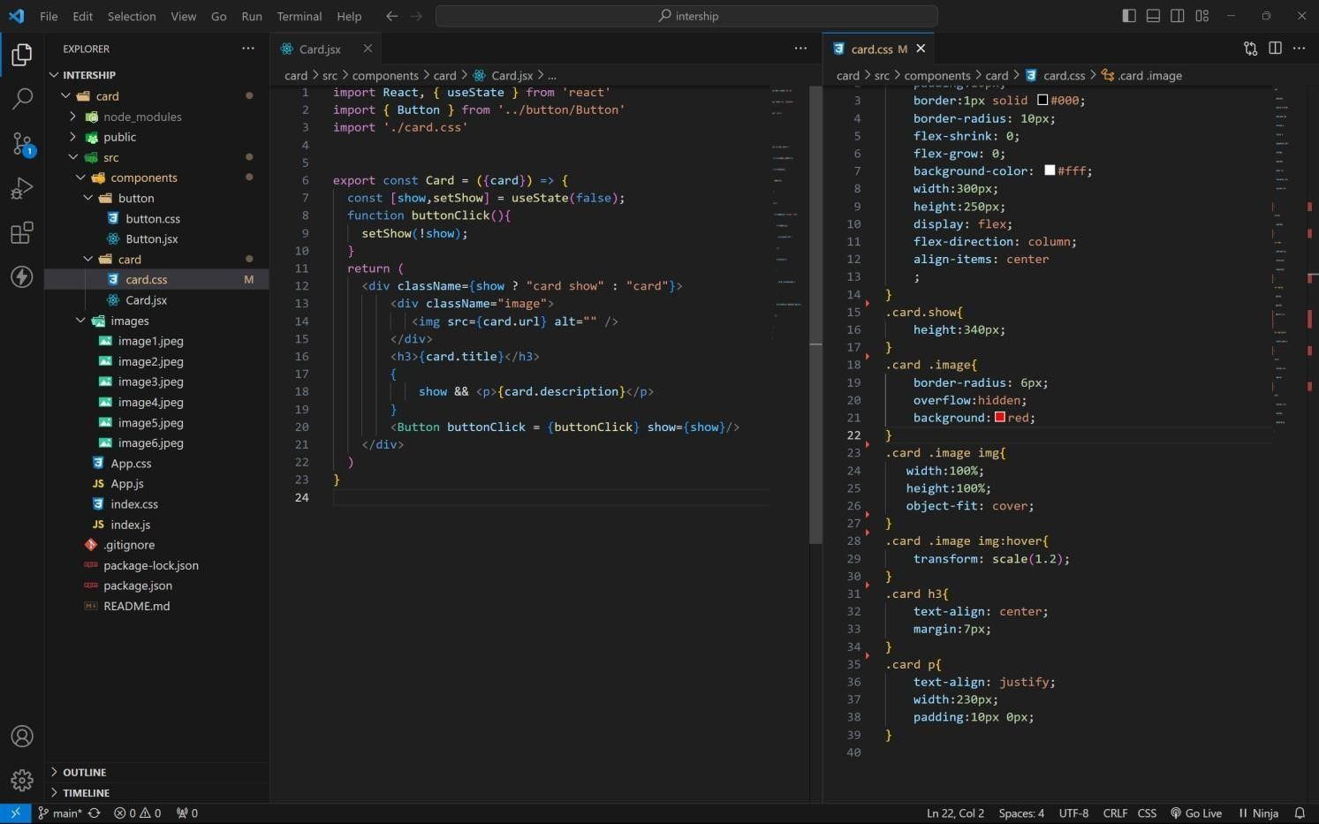

BUTTON COMPONENT:

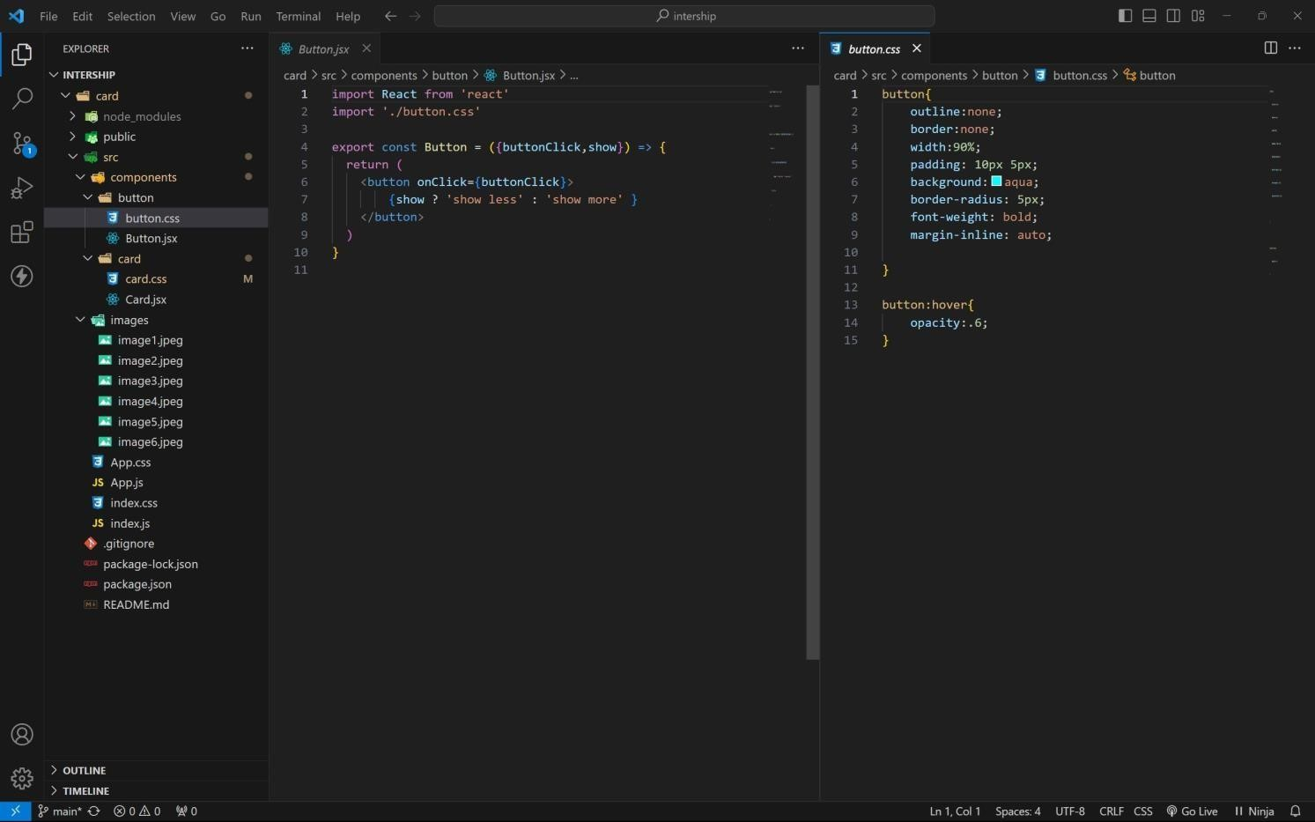

APP COMPONENT:

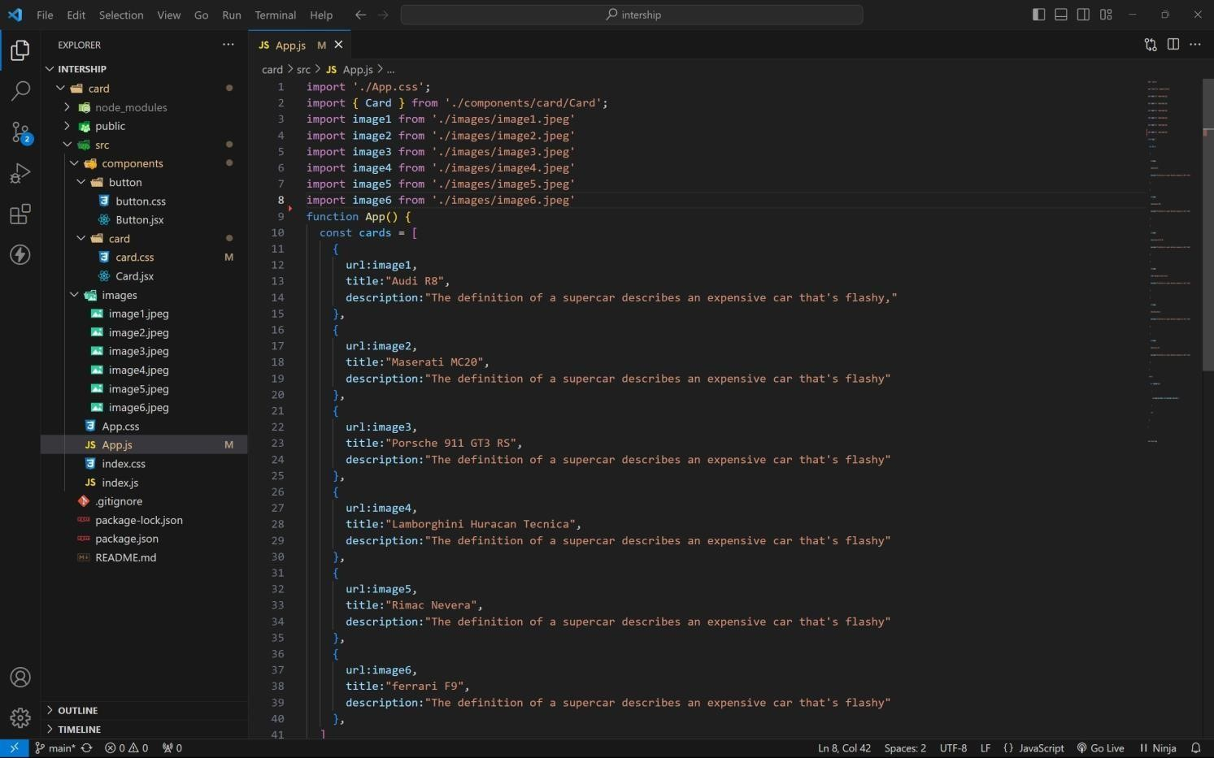

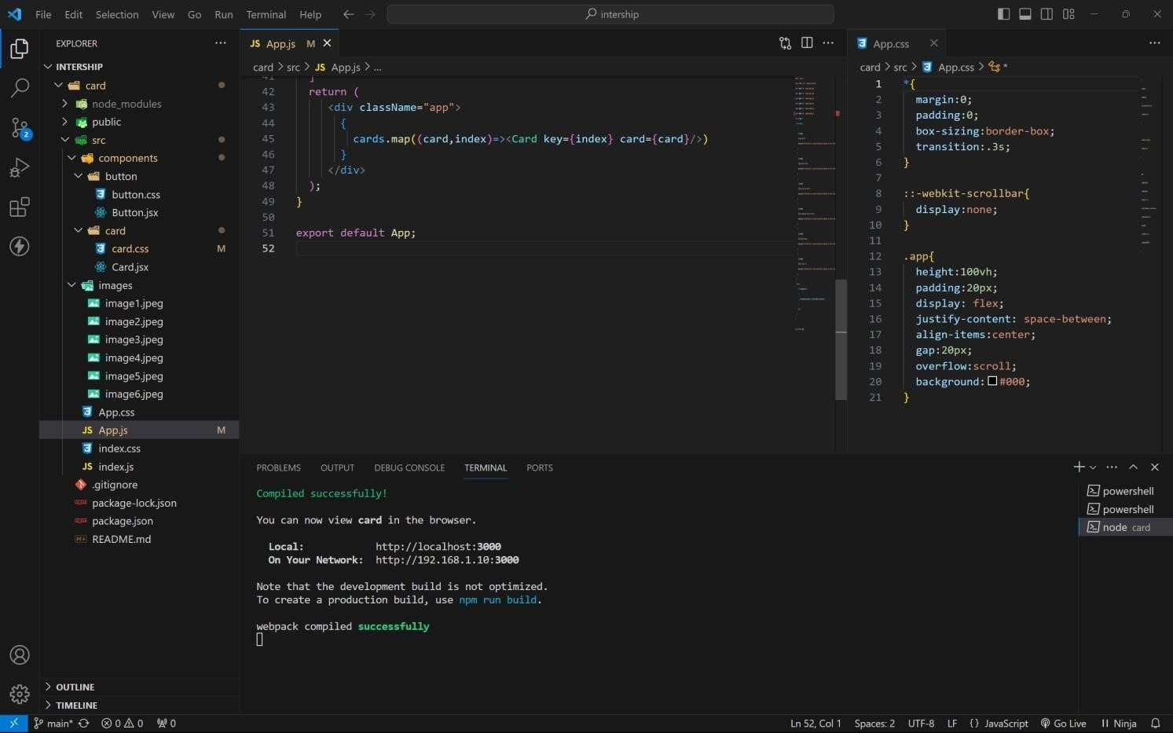

Approach:

1. . initially taking an array of objects like below

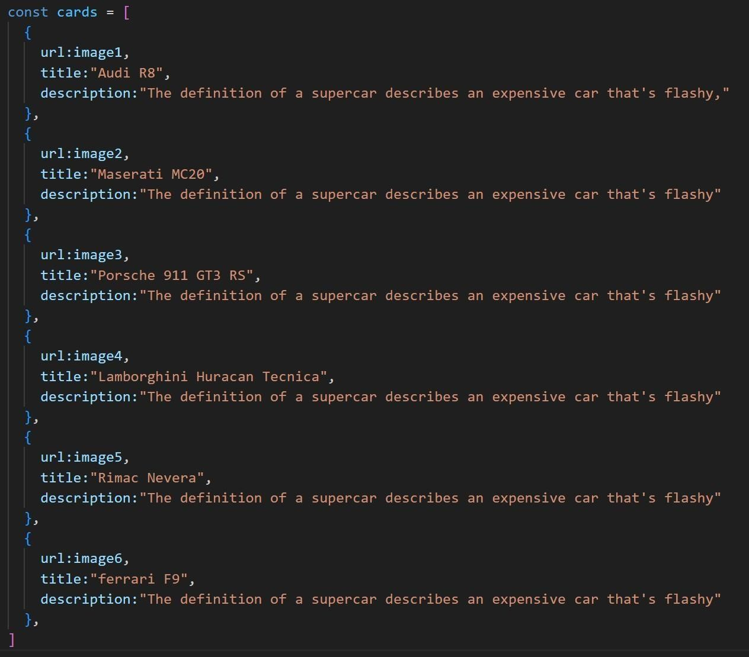

1. . Passing this card array to child (card component) of App component by using props;
2. . getting data as argument like {card} in card component.
3. . in card component i use one state [show, set Show] to get extra info as description.
4. . When we click the button then show becomes true by assigning set Show (! show).

OUTPUT:

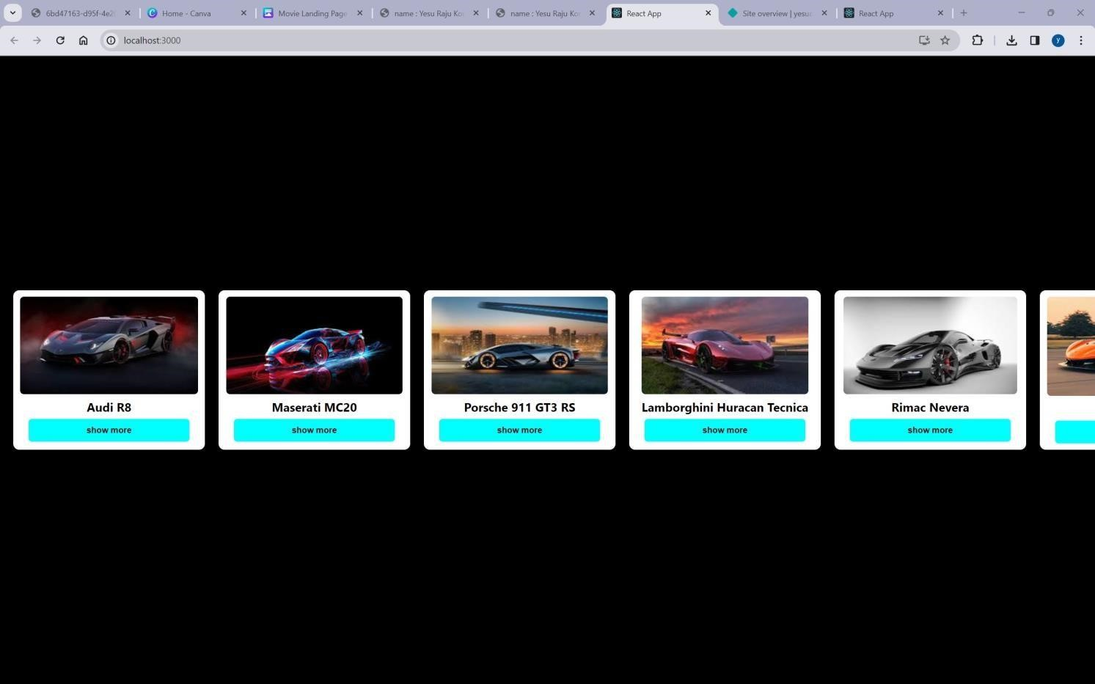

AFTER BUTTON CLICKS:

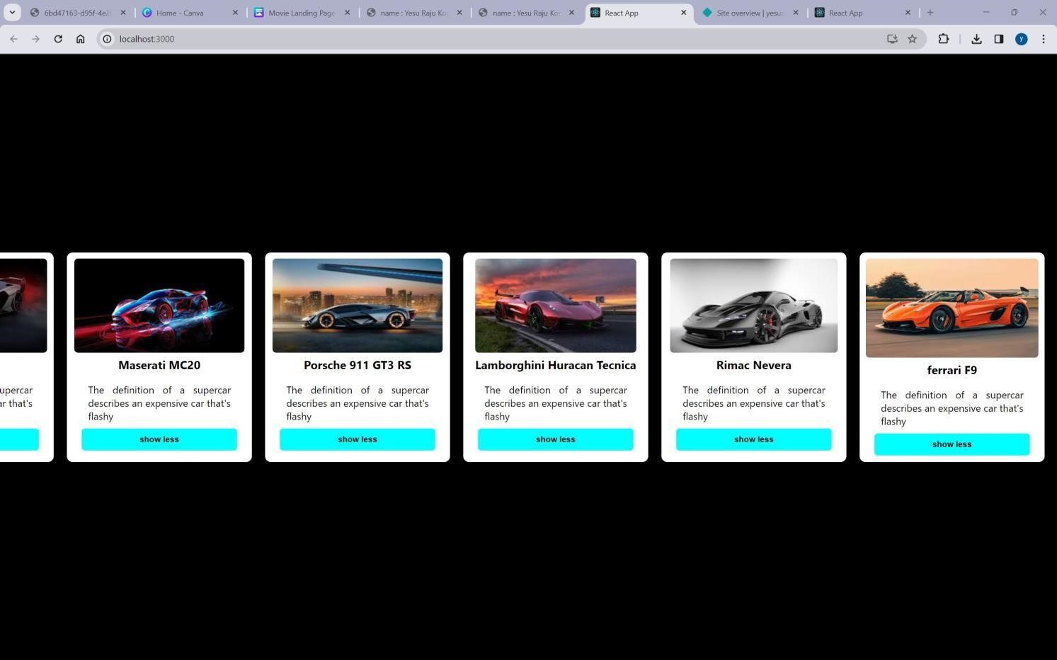

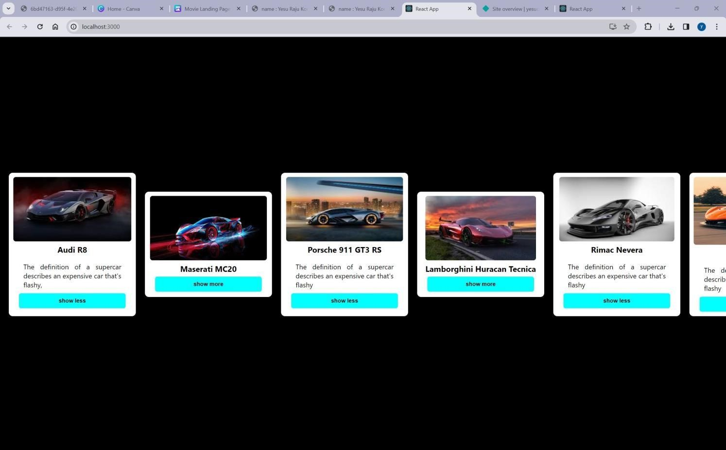

GitHub link:<https://github.com/4727yesuraju/card>live demo: [https://yesucard.netlify.app](https://yesucard.netlify.app/)